# INFORMATION SECURITY

## Assignment – 1

* 1. List the significance of Pseudo Random Number Generator (PRNG) algorithm in context to information security.

-> It is quite efficient where we require multiple random numbers which should not be repeating and it can be done in short period of time.

-> The seed chosen for PRNG should be such that it can’t be predicted at a later stage or it should not be repeating. This is commonly achieved by either using time or date of system or both. This reduces the chances of prediction of numbers.

* 1. Draw the flow diagram of PRNG algorithm of your choice.

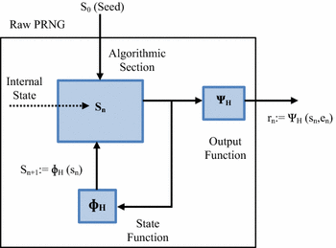

* 1. How the seed value must be supplied to the PRNG according to you. Justify your answer.

-> The seed chosen for PRNG should be such that it can’t be predicted at a later stage or it should not be repeating. This is commonly achieved by either using time or date of system or both. This reduces the chances of prediction of numbers.

* + 1. List the requirements of a PRNG.

The general requirement of secrecy of output of PRNG requires:

-> Randomness

-> Unpredictability

-> Characteristics of the seed

* + 1. Explain Blum Blum Shub Generator with an example.

-> It is basically of form xn+1 = xn2 mod M

-> Eg. Let p=11, q=23 and s=3 (where s is the seed). We can expect to get a large cycle length for those small numbers, because ((p-3)/2,(q-3)/2)=2 ((p-3)/2,(q-3)/2)=2. The generator starts to evaluate x0 by using x-1=s and creates the sequence 9, 81, 236, 36, 31, 202. The following table shows the output (in bits) for the different bit selection methods used to determine the output.

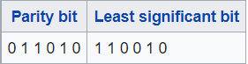

* 1. List the properties of stream cipher.

-> Main function used is XOR

-> Key is generated using PRNGs.

* 1. Explain Stream Cipher structure.

-> In this, each bit of plain text is XORed with the key which is generated randomly which in result gives cipher text, method known as encryption.

-> This cipher text is XORed with same key which again gives the plain text which is method of decryption.

* 1. Which is the stream cipher practically used in SSL/WEP/WPA?

-> Rivest Cipher 4 is used.

* 1. Explain the working of the stream cipher mentioned as answer to a. using a diagram.

-> You input a secret key and the text you'd like to protect.

-> The cipher scrambles your text via encryption. The work happens byte by byte rather than in chunks.

-> Your scrambled text heads to the recipient. That person should have a copy of the secret key you used to protect the data.

-> The recipient walks back through these steps to uncover your original text.

